ASSIGNMENT 6

6.1.
1. Define the task
In the context of an e-commerce system, our goal is to design an AI-based recommendation system that personalizes product suggestions to users based on their historical interactions, reviews, and ratings. This directly contributes to increasing conversion rates and enhancing user engagement. By leveraging large-scale behavioral data such as clickstream logs, purchase history, and time spent viewing products, the system can infer user preferences with higher precision. Furthermore, incorporating textual reviews and sentiment analysis allows the AI model to capture qualitative aspects of user opinions, helping to recommend products that not only match purchase patterns but also align with personal tastes and satisfaction levels. Over time, the recommendation engine can dynamically adapt to seasonal trends, new product releases, and evolving user behavior, ensuring that suggestions remain relevant and timely. In addition, personalization fosters stronger customer loyalty, reduces decision fatigue, and creates a seamless shopping experience similar to that of a personal shopping assistant powered by artificial intelligence. Ultimately, such an intelligent recommendation system becomes a core driver of business value—boosting sales performance, improving customer retention, and enabling data-driven marketing strategies within the e-commerce ecosystem.
a. Problem framing
- We define the problem as predicting which items a user is most likely to interact with or purchase. This can be treated as a supervised learning task where the input is user–item interaction data and the output is a ranked list of recommended products. Each interaction, such as viewing, adding to cart, or purchasing, provides implicit feedback that helps the model learn user intent and preference patterns. The dataset may also include contextual features like time of day, device type, or product category, which allow the model to adapt to situational factors influencing buying behavior. Through iterative training, the recommendation algorithm (for example, collaborative filtering or neural embeddings) learns to predict similarity between users and items, enabling it to suggest products that align closely with an individual’s interests. The end goal is to create a recommendation list that maximizes user satisfaction, click-through rate (CTR), and conversion probability, ultimately driving both engagement and revenue growth.
- The e-commerce company also aims to identify which customers are likely to stop purchasing (churn) so that proactive retention campaigns can be launched. This represents a binary classification task: classifying a customer as either will churn (1) or will not churn (0). In this scenario, historical transaction data, frequency of visits, changes in purchase volume, and customer service interactions become critical predictors. Additional behavioral indicators such as declining session duration, reduced engagement with marketing emails, or negative product feedback may also signal churn risk. By training a machine learning model (such as logistic regression, random forest, or deep neural network) on these features, the company can predict potential churners early and implement personalized retention strategies—such as discount offers, re-engagement messages, or loyalty rewards. This proactive use of AI not only minimizes revenue loss but also enhances long-term customer satisfaction and lifetime value (CLV).

b. Choose a measure of success
- Since churned customers are typically a small fraction of the total customer base, relying solely on accuracy can be misleading. In highly imbalanced datasets, a model could achieve high accuracy simply by predicting the majority class (non-churn) most of the time, while still failing to identify customers who are actually at risk of leaving. Therefore, more informative evaluation metrics such as the F1-score, Precision-Recall (PR) curve, and ROC AUC (Area Under the Receiver Operating Characteristic Curve) should be prioritized. The F1-score balances precision and recall, ensuring that both false positives and false negatives are minimized — a crucial aspect when the goal is to detect true churners without over-alerting non-churners. The ROC AUC, on the other hand, measures the model’s ability to distinguish between churn and non-churn classes across various threshold settings, offering a more comprehensive view of performance under imbalance. In practical applications, it is also beneficial to complement these metrics with business-oriented indicators such as the retention lift from targeted campaigns or the cost-benefit ratio of customer retention efforts. Together, these measures provide a holistic understanding of model effectiveness in identifying and preventing churn.
c. Data collection
The data sources include:
- User profiles: demographic information such as age, gender, and location, along with behavioral signals like browsing history, purchase frequency, preferred categories, and device usage. These attributes help the system model long-term preferences and personalize recommendations at the individual level.
- Product data: structured attributes such as category, price, brand, and availability, as well as unstructured data like textual descriptions and product images. This information is crucial for content-based filtering, enabling the model to understand item similarity through embeddings derived from both text (e.g., BERT) and visual features (e.g., CNNs).
- Transaction data: records of user–item interactions, including ratings, timestamps, cart activity, payment methods, and discount usage. Temporal patterns extracted from this data allow the AI model to capture seasonality, trends, and purchasing cycles.
- Review data: user-generated feedback in the form of text reviews and sentiment ratings, which provide deeper insights into user satisfaction and product quality. Sentiment analysis models can convert these qualitative opinions into quantitative sentiment scores, improving recommendation accuracy and product ranking.
All these data sources are integrated into a structured and unified data warehouse using ETL (Extract–Transform–Load) pipelines for preprocessing and training. Data consistency, deduplication, and anonymization are maintained to comply with privacy regulations such as GDPR and PDPA. This unified dataset forms the foundation of the AI pipeline, supporting model training, validation, and continuous learning in production.

d. Code example – data loading and overview
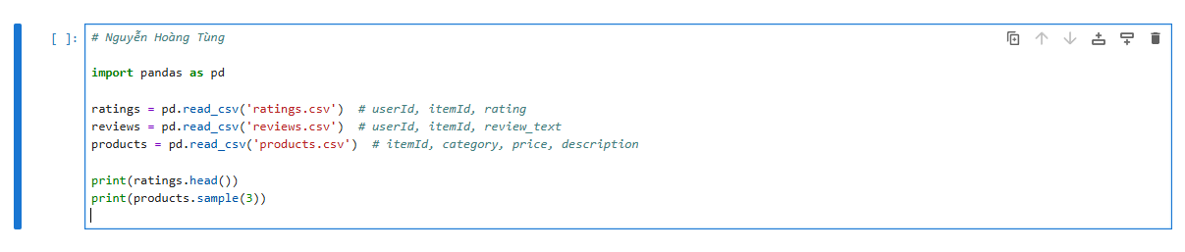

2. Develop a model
This phase involves preparing data, selecting an evaluation protocol, establishing baselines, and iteratively improving the model. It represents the core of the machine learning workflow, where raw data is transformed into actionable insights through systematic experimentation. Data preparation includes cleaning, normalization, feature engineering, and handling missing or inconsistent records to ensure the dataset is both accurate and representative. Selecting an appropriate evaluation protocol—such as k-fold cross-validation or a temporal split for time-sensitive data—ensures that model performance is measured reliably and generalizes well to unseen data. Baseline models, such as simple collaborative filtering or popularity-based recommenders, are first established to provide a reference point for improvement. Subsequent iterations involve experimenting with more advanced architectures (e.g., neural collaborative filtering, hybrid models combining text and image features) and tuning hyperparameters to optimize performance. Throughout this process, metrics such as RMSE, Precision@K, Recall@K, and AUC are used to quantitatively assess model effectiveness, while qualitative evaluations—such as human inspection of recommendations—help ensure practical relevance. The iterative cycle of experimentation, validation, and refinement ultimately leads to a model that balances predictive accuracy, scalability, and interpretability.
a. Data preparation and preprocessing
- Real-world e-commerce data often requires extensive preprocessing — including cleaning, encoding, and scaling — before it can be effectively used for machine learning. Transactional and behavioral datasets are typically heterogeneous, combining numerical features (prices, quantities), categorical variables (brands, product categories), textual data (reviews, descriptions), and timestamps. Inconsistent formats, duplicate records, and missing values are common, especially when data originates from multiple sources such as web logs, CRM systems, and product catalogs. Therefore, preprocessing ensures that the data is consistent, normalized, and transformed into a format suitable for model ingestion. Feature encoding techniques such as one-hot encoding, label encoding, or learned embeddings are applied to categorical attributes, while numerical features are standardized or min–max scaled to stabilize gradient-based optimization. This stage also involves aligning user and product identifiers across datasets to maintain relational integrity within the recommendation framework.
- Data cleaning encompasses multiple essential operations such as handling missing ratings, normalizing numerical scores, and preparing text data for embedding-based learning. Missing ratings may be imputed using statistical methods (mean, median, or collaborative prediction) to prevent bias, while normalization scales rating values into a uniform range (e.g., [0, 1]) for better model convergence. Text preprocessing, particularly for product reviews, includes tokenization, lowercasing, and the removal of punctuation and special characters. Stop words and meaningless tokens are filtered out to retain only semantically rich content. More advanced preprocessing techniques, such as stemming or lemmatization, further refine textual inputs. These cleaned and structured text corpora are then transformed into vector representations—using TF-IDF, Word2Vec, or contextual embeddings (like BERT)—which capture the sentiment and thematic nuances of user feedback. By performing these steps carefully, the data becomes both machine-readable and semantically informative, ensuring that downstream AI models can learn accurate and generalizable patterns.
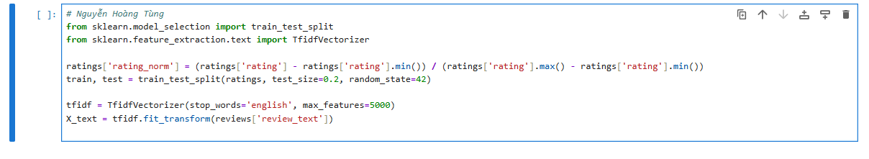

b. Model development
We begin with a simple Collaborative Filtering baseline using matrix factorization, then enhance
it with neural networks such as embeddings or LSTM for text-based context.
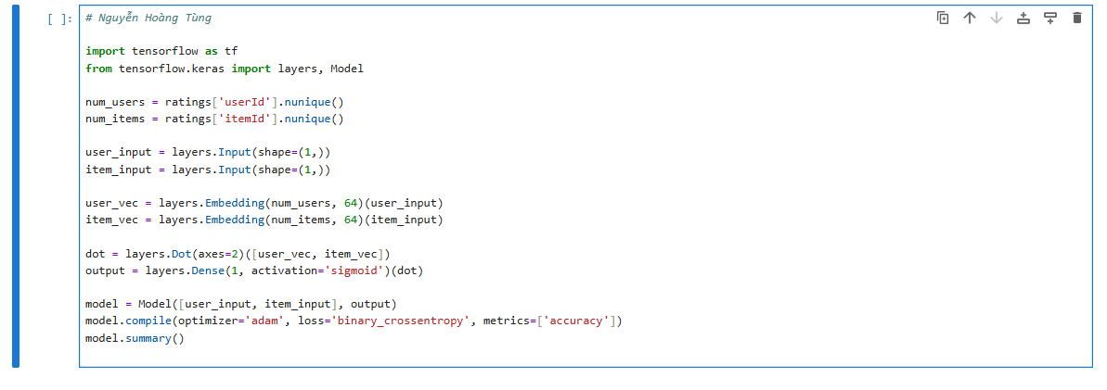

c. Training and validation
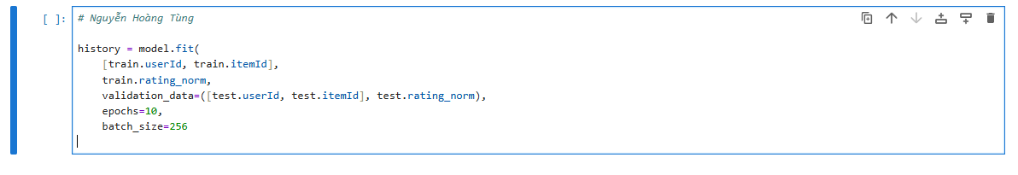

d. Regularization and tuning
- If the model overfits, dropout and early stopping are applied. Chapter 5 techniques like L2 regularization help generalization.
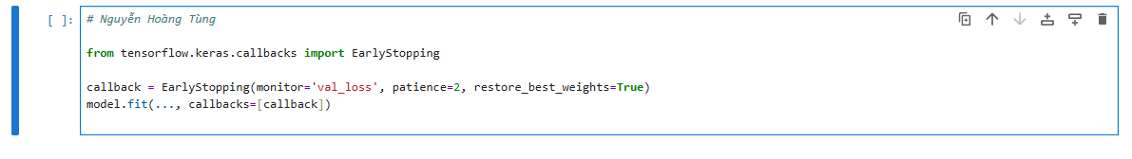

3. Deploy the model
- The deployment phase focuses on integrating the trained model into a real-time environment and communicating results to stakeholders.
- The final phase involves preparing the model for real-world use, often by shipping it as an inference service (e.g., a REST API) and establishing a monitoring and maintenance plan.
a. Inference API example
- The trained model is saved and deployed, perhaps as a microservice on a cloud platform (e.g., AWS SageMaker or a custom Flask application). It must accept new customer data and return a churn probability.
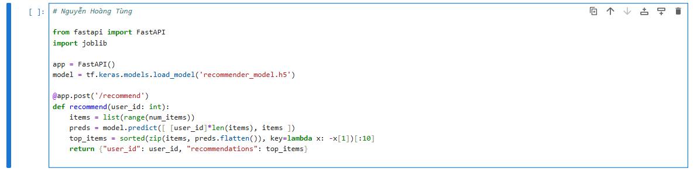

b. Monitoring and maintenance
- In production, model drift is continuously monitored by tracking changes in prediction distributions, user behavior patterns, and feedback quality over time. Model drift occurs when the underlying data distribution shifts—due to new products, seasonal changes, evolving customer preferences, or external market factors—causing the model’s performance to degrade. To detect such drift, monitoring dashboards visualize key indicators such as prediction confidence trends, accuracy decay, and discrepancies between expected and observed user interactions (for example, declining click-through or conversion rates). User feedback and A/B testing results further provide real-world validation of model relevance. Once drift is detected, the system triggers retraining pipelines that automatically extract, clean, and integrate fresh transactional data, typically on a monthly or bi-weekly basis. These pipelines leverage automated data versioning, feature stores, and continuous integration workflows (CI/CD for ML, or MLOps) to ensure reproducibility and deployment efficiency. The retrained model is then validated against the previous production version using backtesting and champion–challenger evaluations before rollout. This ongoing cycle of monitoring, retraining, and redeployment ensures that the recommendation system remains accurate, adaptive, and aligned with dynamic e-commerce business conditions.

c. Extending the system
- The next steps involve integrating deep text models, such as BERT-based embeddings for review sentiment analysis, and expanding the recommendation framework into a multi-modal learning system that incorporates visual, textual, and behavioral data. By leveraging pre-trained language models like BERT or RoBERTa, the system can capture nuanced sentiment and contextual meaning from customer reviews, enabling it to infer user satisfaction and product quality beyond simple rating scores. These embeddings can be combined with product metadata to enhance similarity computation and personalization. In parallel, integrating product images using convolutional neural networks (CNNs) or vision transformers (ViTs) allows the recommendation model to learn visual attributes—such as color, design, or style—that strongly influence consumer decisions in categories like fashion and electronics.
Ultimately, the architecture can evolve toward a reinforcement learning (RL) paradigm, where the system dynamically adapts recommendations in response to real-time user interactions, such as clicks, dwell time, or purchases. Through exploration and exploitation strategies, the RL agent learns to optimize long-term engagement and lifetime value rather than short-term metrics alone. This transition from static recommendation to adaptive decision-making represents a key milestone in developing an intelligent, self-improving e-commerce AI ecosystem that continuously learns from user behavior and market trends.

6.2.
a.
1. High-level goal
Design, implement, evaluate, and document an end-to-end AI product for an e-commerce platform that comprises:
- A recommendation engine that produces personalized ranked product suggestions for each user.
- A churn prediction model to flag customers likely to stop purchasing so the business can run retention campaigns.
- A text-analysis subsystem to extract sentiment and product/feature preferences from Vietnamese reviews and incorporate these signals into recommendations.
The final deliverable is a reproducible Jupyter-based project demonstrating dataset generation, modeling experiments, evaluation (figures + metrics), brief discussion of structure/improvements, and deployment-ready inference stubs.

2. Concrete subgoals / outcomes (what you need to obtain)
- Synthetic (or semi-simulated) dataset meeting assignment spec:
  - 1000 users, 500 items.
  - Ratings on a 1–5 star scale.
  - Each user provides ~50 textual reviews (Vietnamese) across items.
  - Exported CSVs: users.csv, items.csv, ratings.csv, reviews_<yourname>.csv.
- Preprocessing pipeline:
  - Data cleaning, rating normalization, ID alignment, Vietnamese text tokenization and stopword removal, text-to-vector via Word2Vec and BERT embeddings (or placeholders if computing resources limited).
- Baseline models:
  - Popularity / item-popularity recommender (baseline).
  - Matrix factorization (ALS or MF with embeddings).
- Enhanced models:
  - Neural Collaborative Filtering (Keras/TensorFlow embedding-based model).
  - Hybrid models that fuse review text embeddings (Word2Vec / BERT) with collaborative signals.
- Churn prediction model:
  - Binary classifier (Logistic Regression and a neural net baseline) with evaluation (Precision, Recall, F1, ROC AUC).
- Training & evaluation artifacts:
  - Learning curves, Precision@K / Recall@K / MAP, ROC AUC, confusion matrix for churn, example recommendation lists.
- Discussion & improvements:
  - Structural changes made during experiments (embedding sizes, regularization, sequence models for reviews), rationale and observed effects.
- Deployment stub:
  - A minimal inference API example (FastAPI/Flask notebook cell) demonstrating how to query recommendations for a user.

3. Success criteria & evaluation metrics
Recommendation system
- Offline metrics:
  - Precision@K, Recall@K, NDCG@K (K = 5, 10).
  - Compare against popularity baseline — target: consistent uplift (e.g., >10% relative improvement) on Precision@10.
- Business proxies:
  - Simulated CTR or average predicted purchase probability on held-out data.
Churn model
- Because churn is imbalanced:
  - F1-score (primary), Precision-Recall curve, ROC AUC (secondary).
  - Monitor recall at acceptable precision (e.g., recall at precision ≥ 0.6).
- Business proxy:
  - Estimated retention lift and cost-benefit for targeted campaigns.
Text analysis
- Qualitative validation of embeddings: nearest neighbours for keywords, cluster coherence.
- Sentiment accuracy on small annotated sample (if available).

4. Data / assumptions / constraints
- Assignment requires Vietnamese reviews — if real Vietnamese data is unavailable, synthetic Vietnamese-like phrases will be generated. Later improvement: swap synthetic content with real scraped/reused open-source Vietnamese reviews if allowed.
- Compute: models must run on a typical student machine (CPU) or free Colab GPU. Use small embedding sizes and limited epochs for experiments to keep runtime practical.
- Privacy: generated dataset contains no real personal data.

5. Risks & mitigation
- Imbalanced churn labels → mitigate via stratified sampling, class weighting, resampling (SMOTE) and threshold tuning.
- Long runtime for BERT → use precomputed lightweight sentence-transformer or use a smaller multilingual-BERT with caching; provide fallback Word2Vec/Tfidf baseline.
- Synthetic reviews may not fully reflect real language nuances → clearly caveat results and show pipeline works; indicate how to replace synthetic reviews with real ones later.

b.
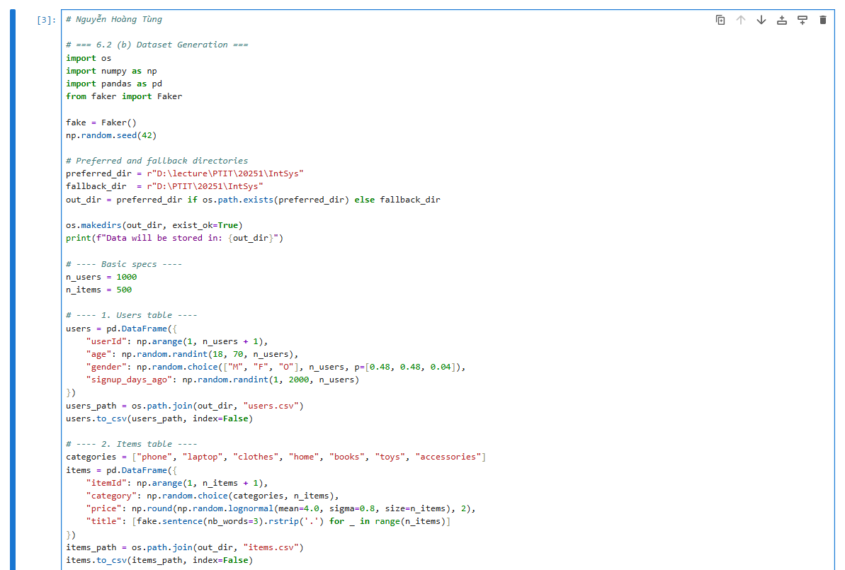
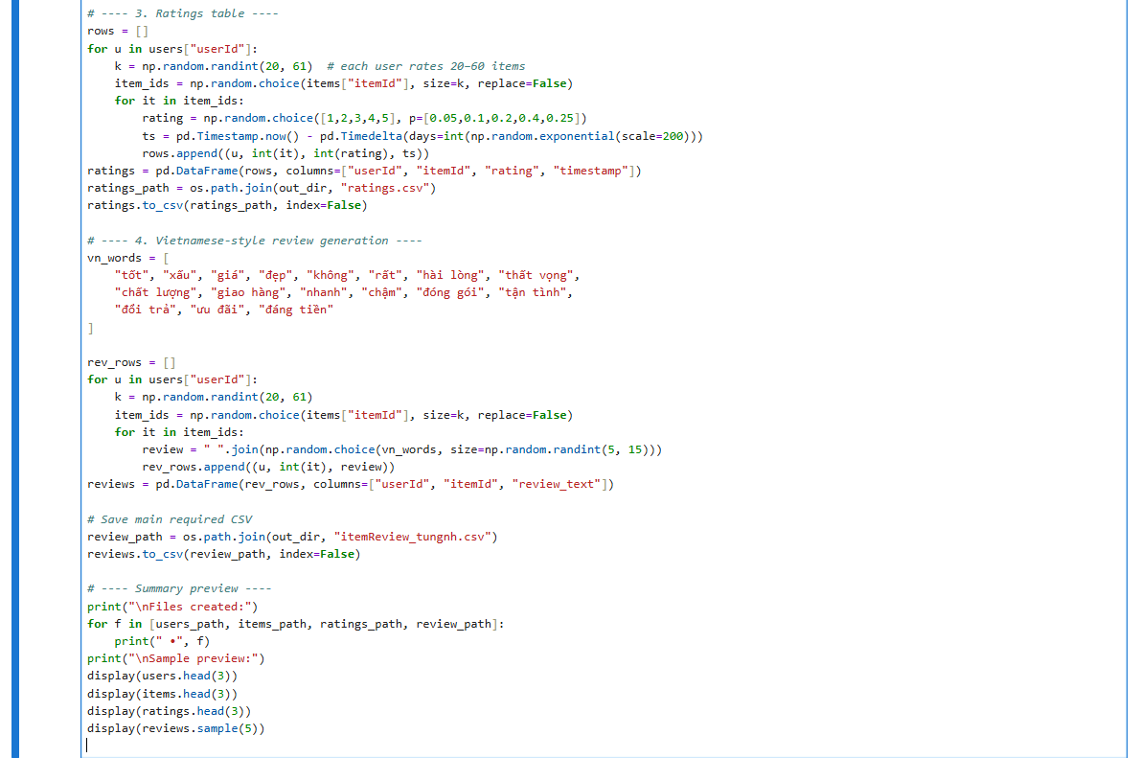
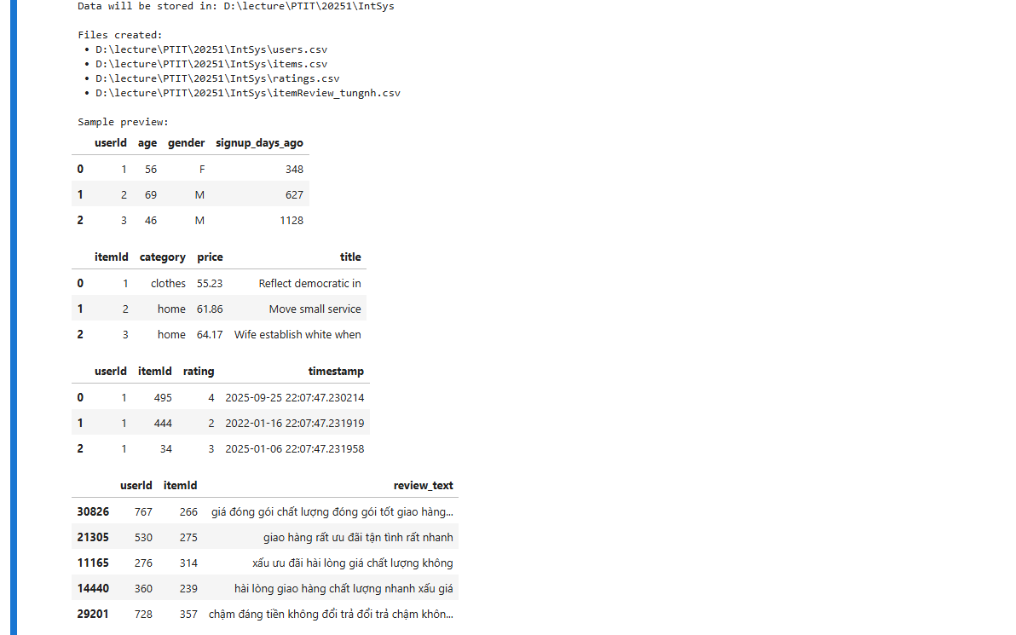

c.
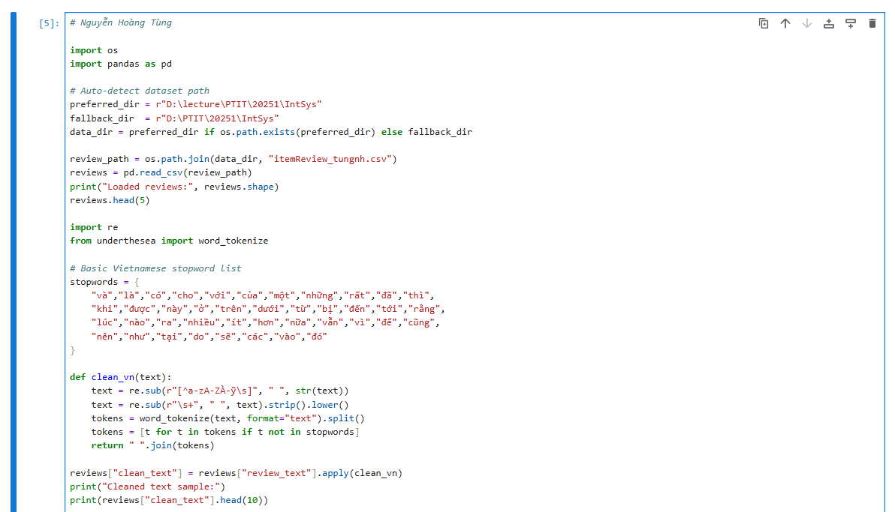
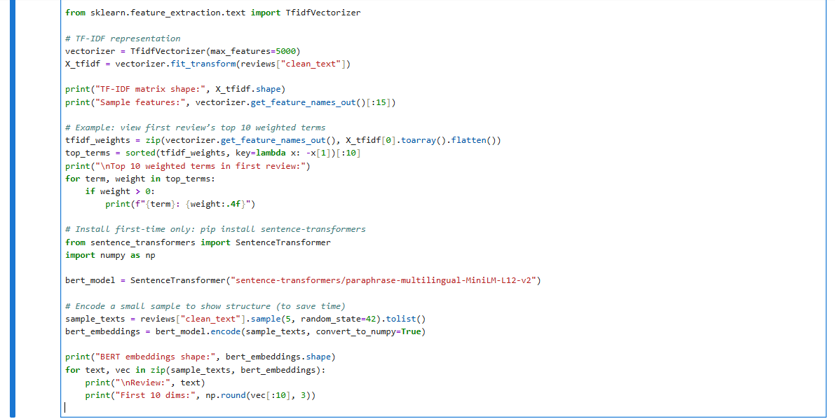
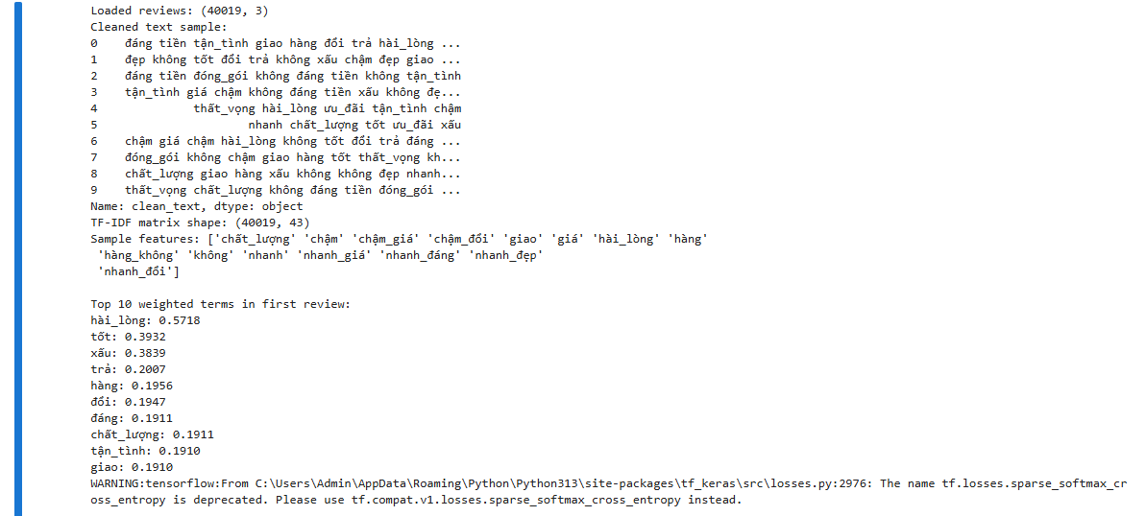


d.
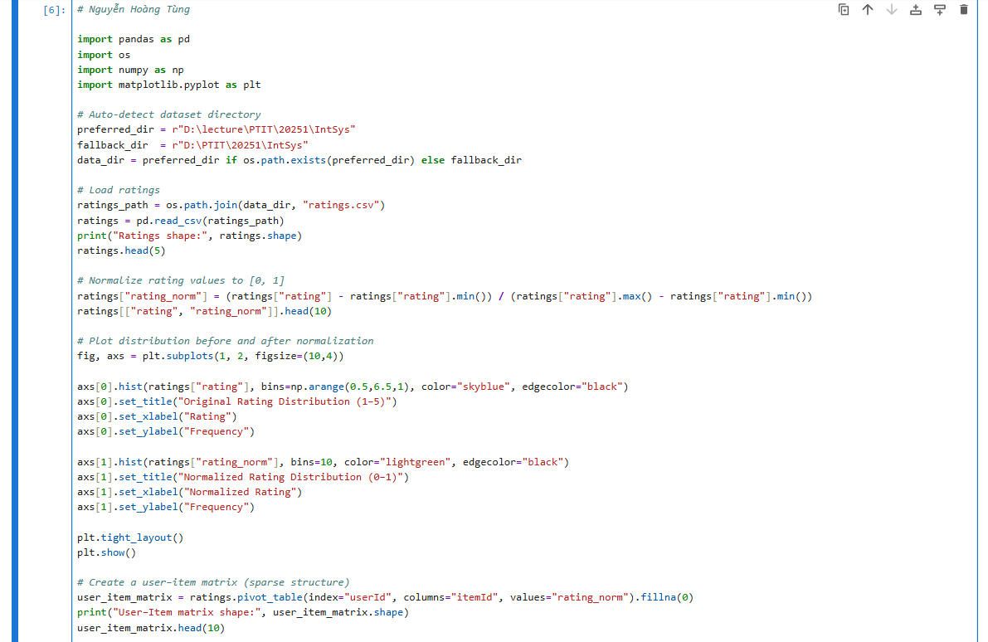
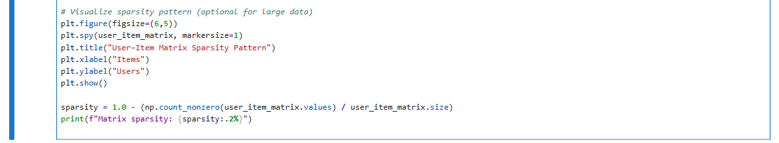
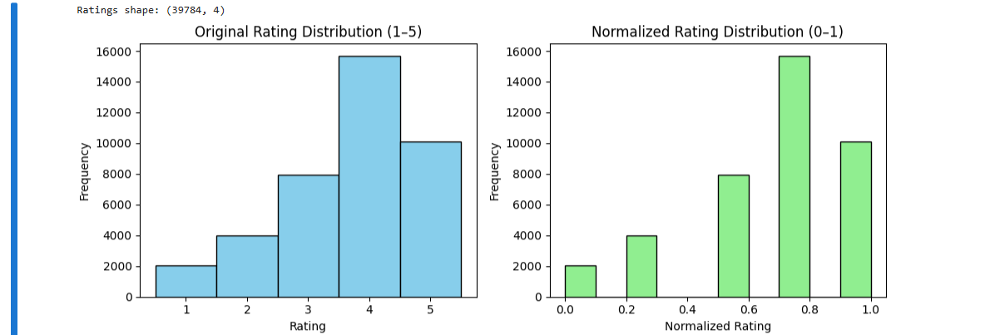
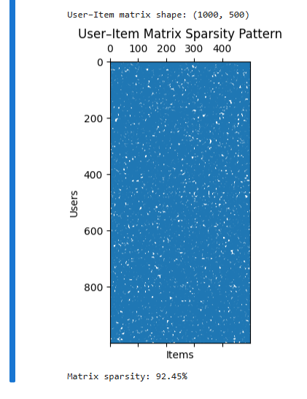

e.
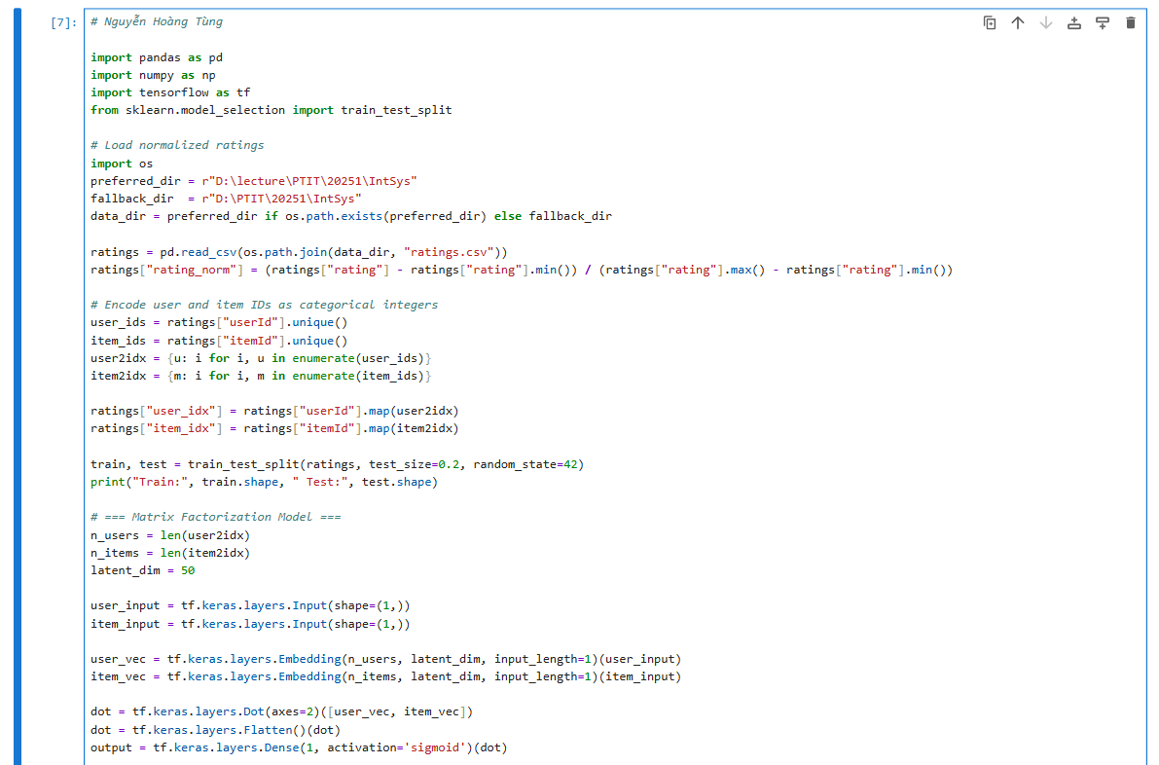
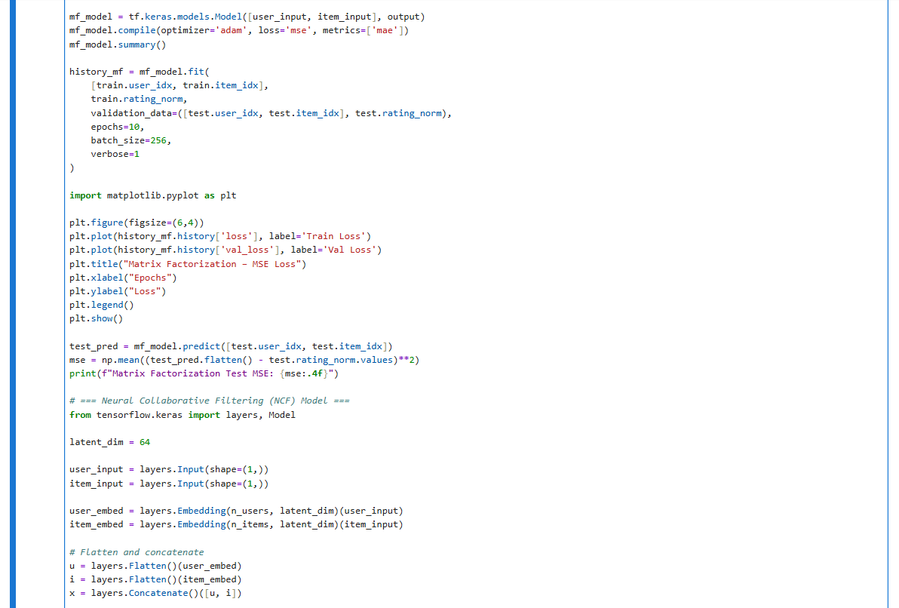
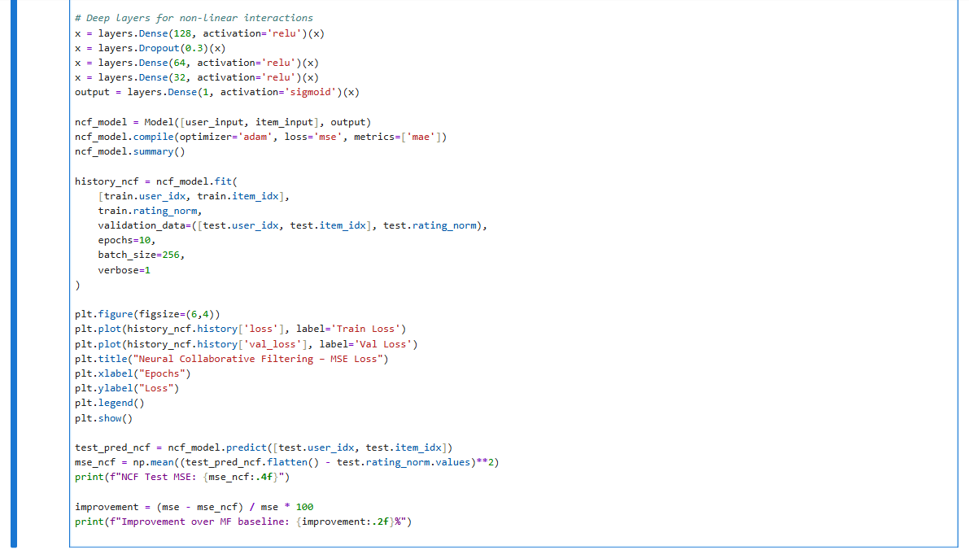
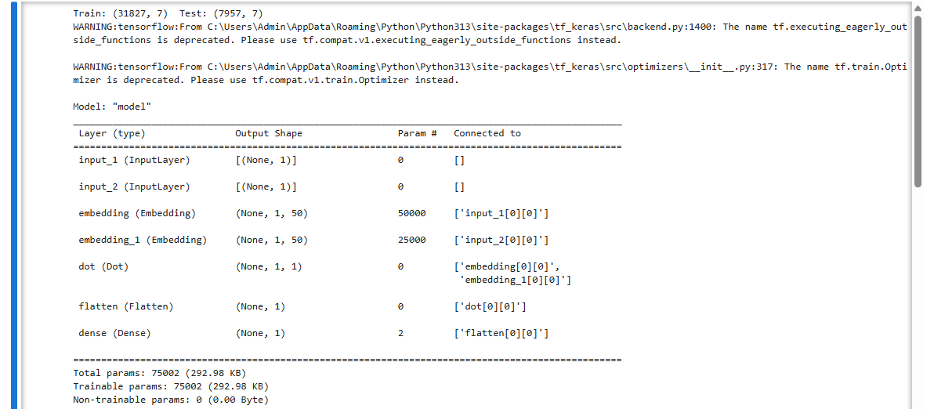
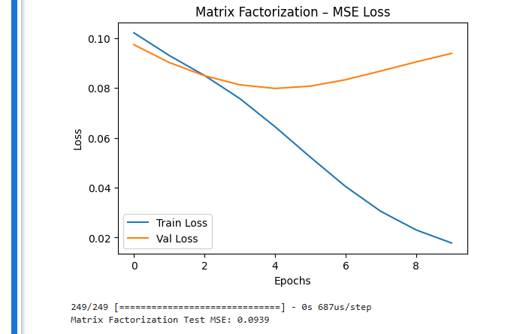
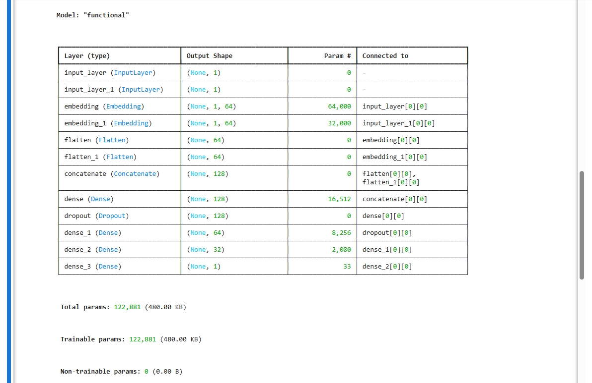
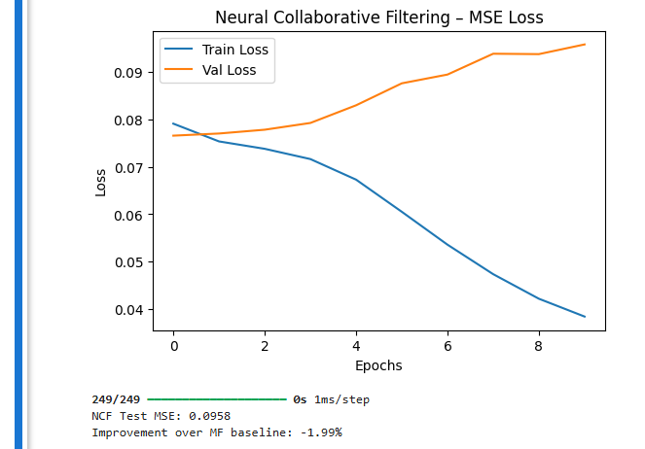

f.
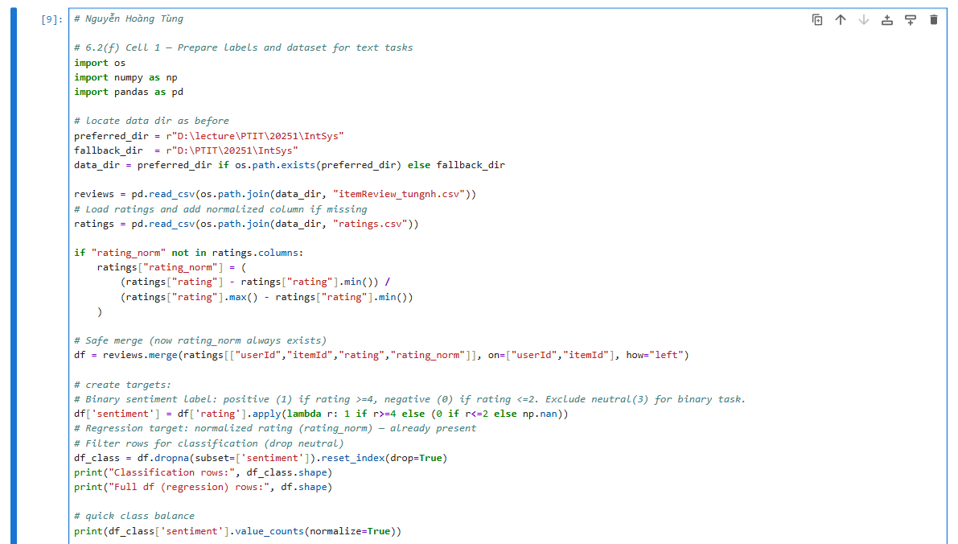
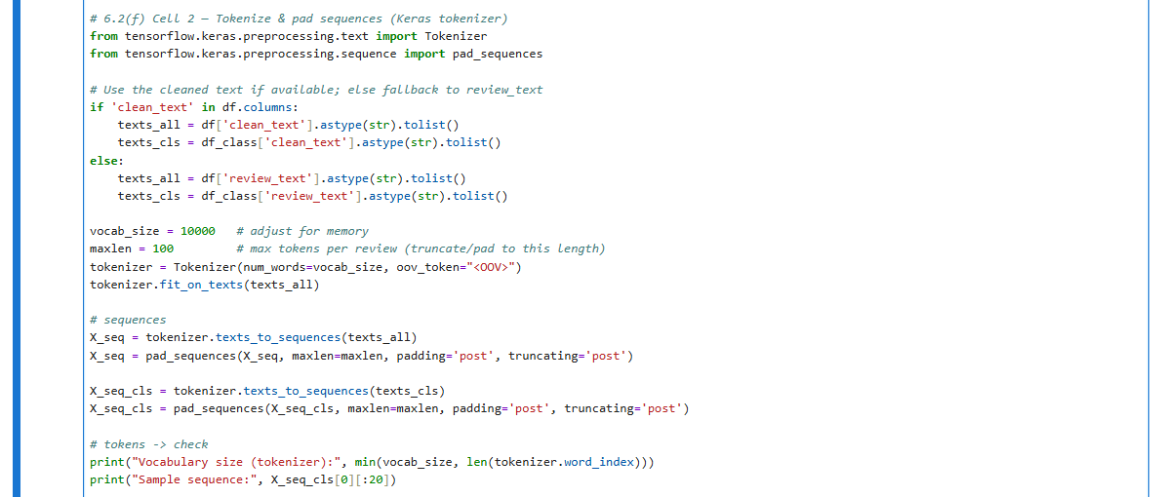
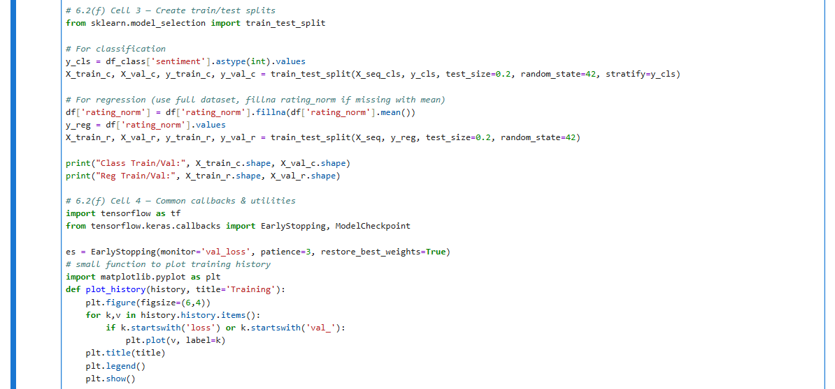
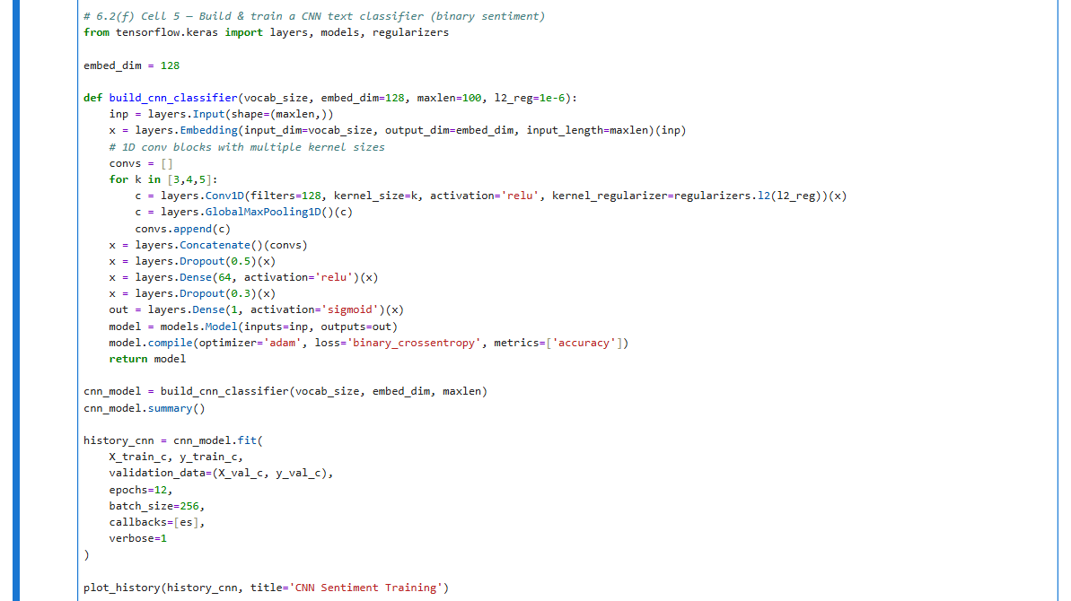
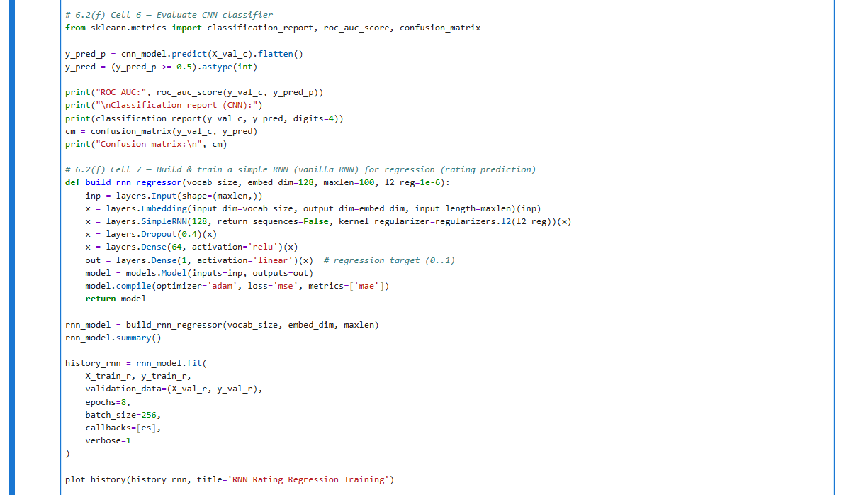
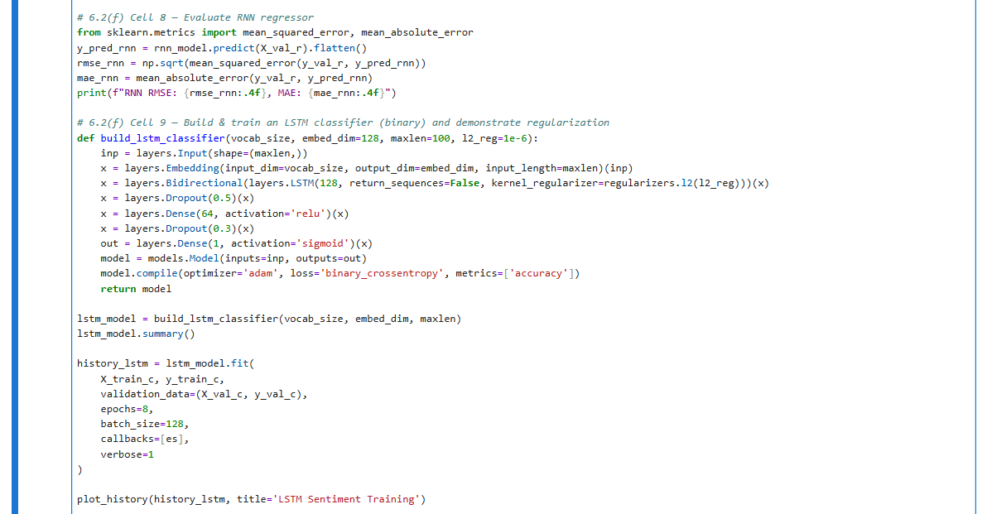
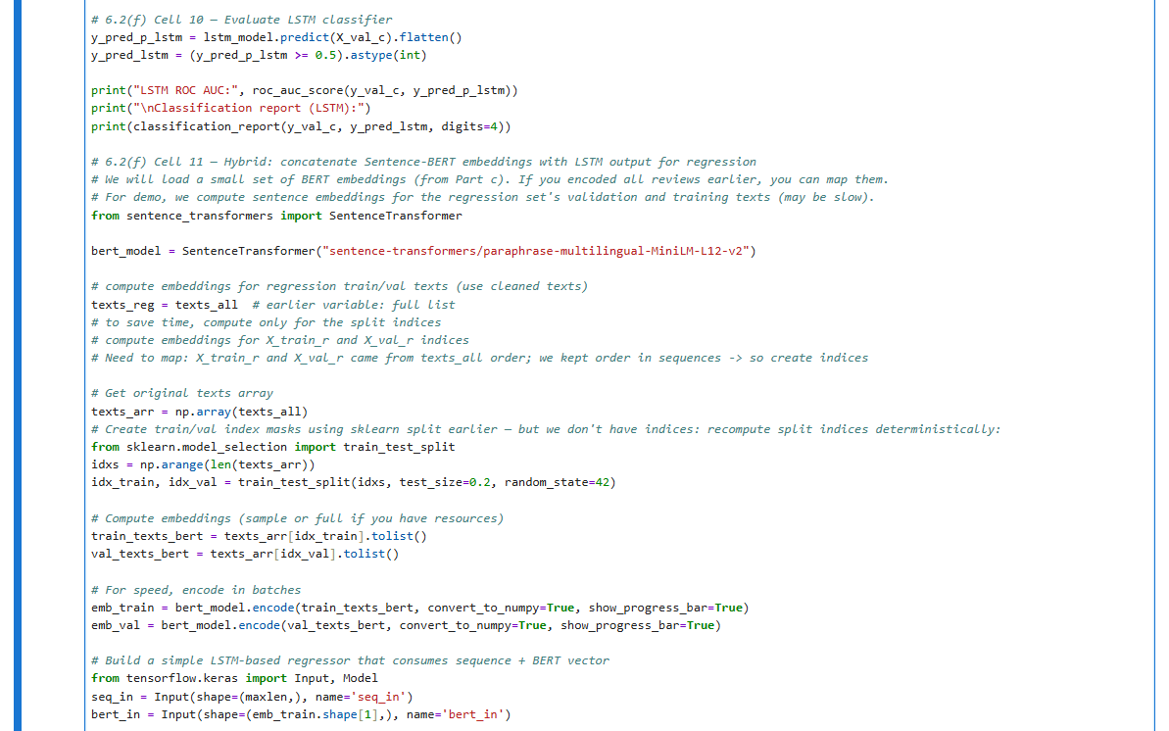
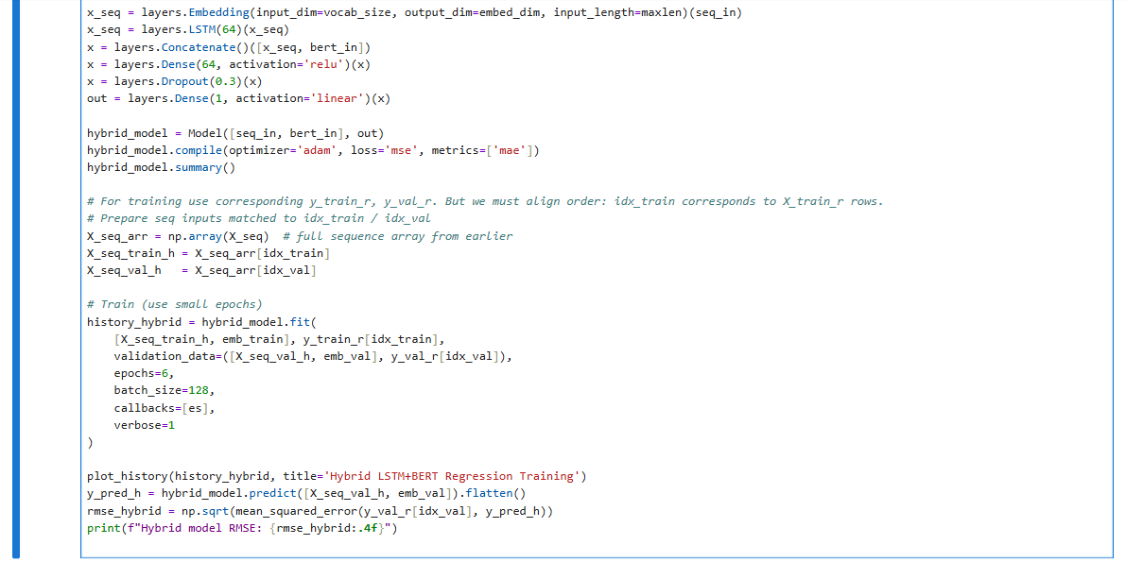
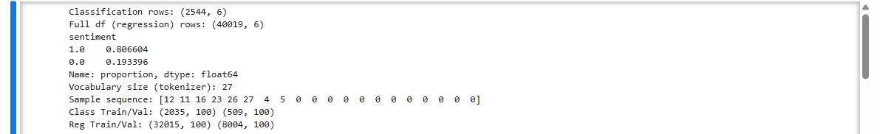
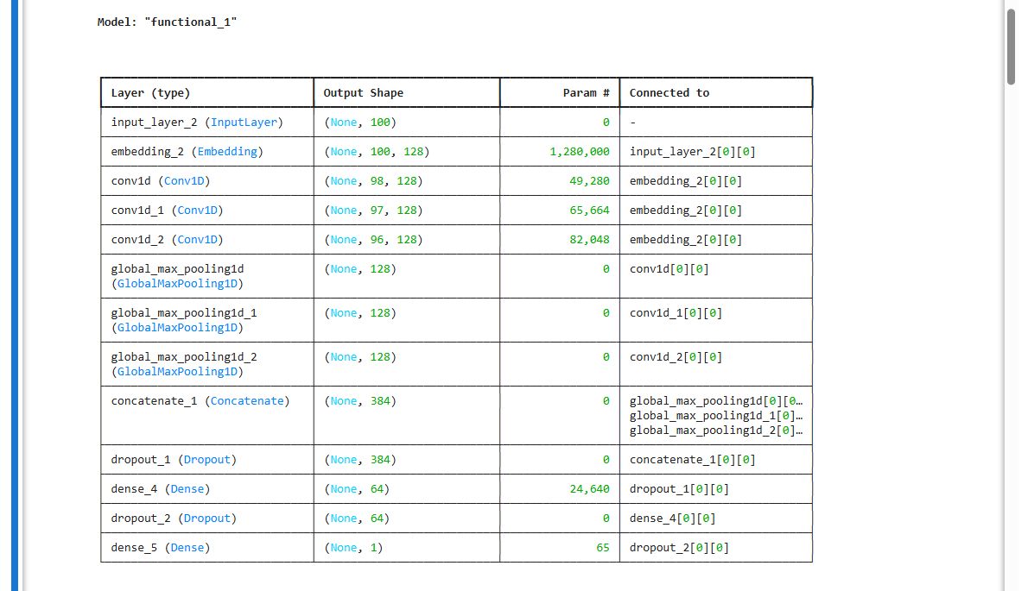
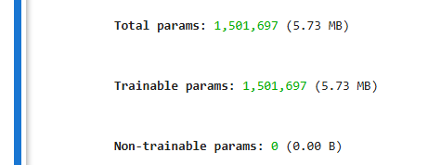
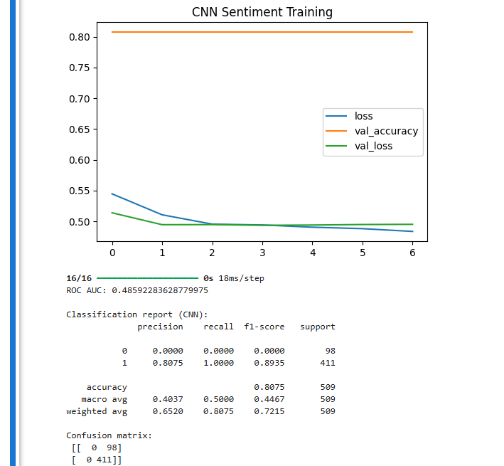
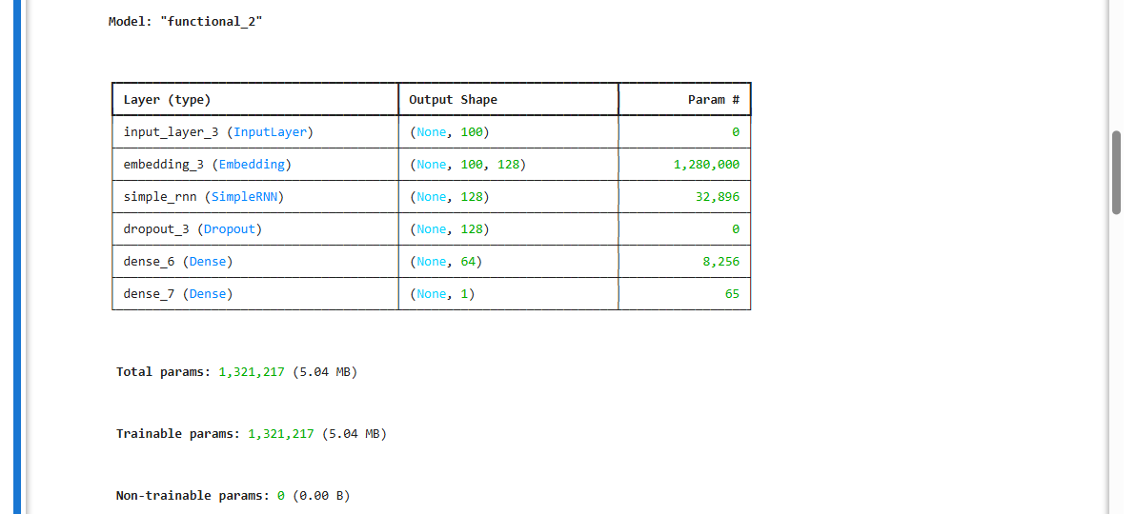
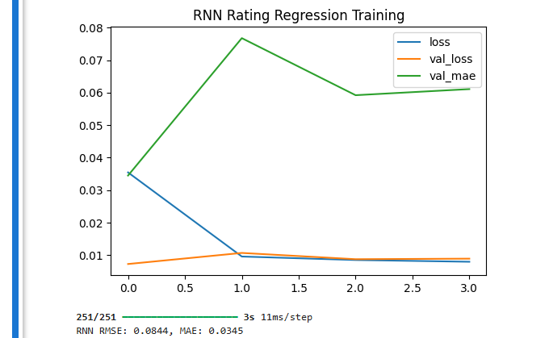
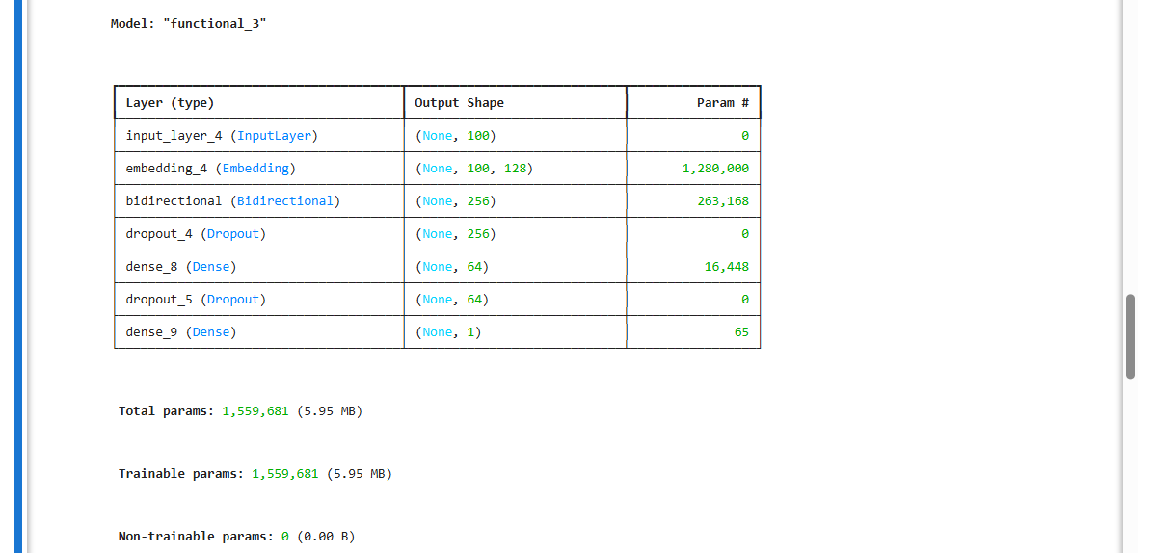
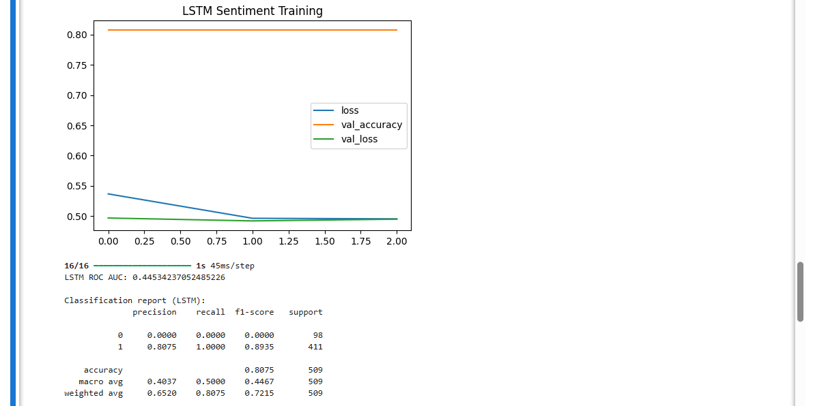
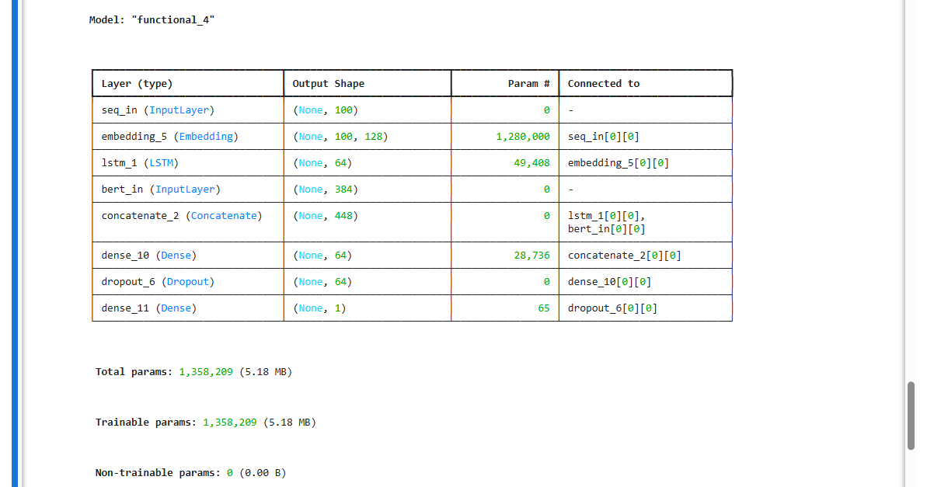

g.
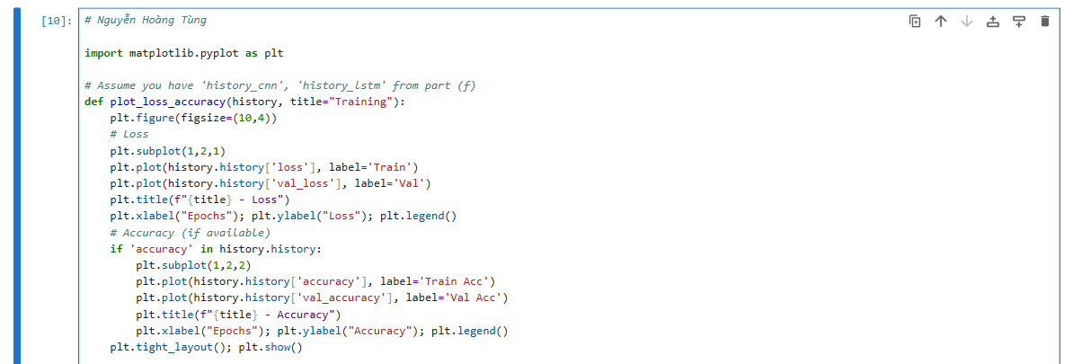
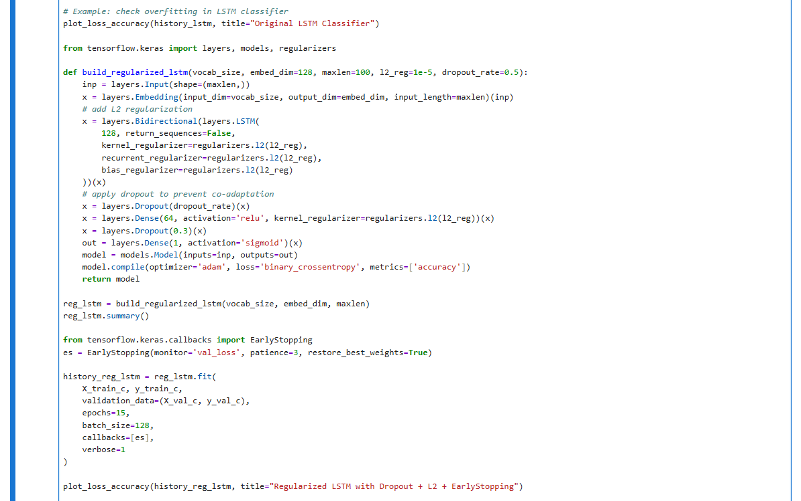
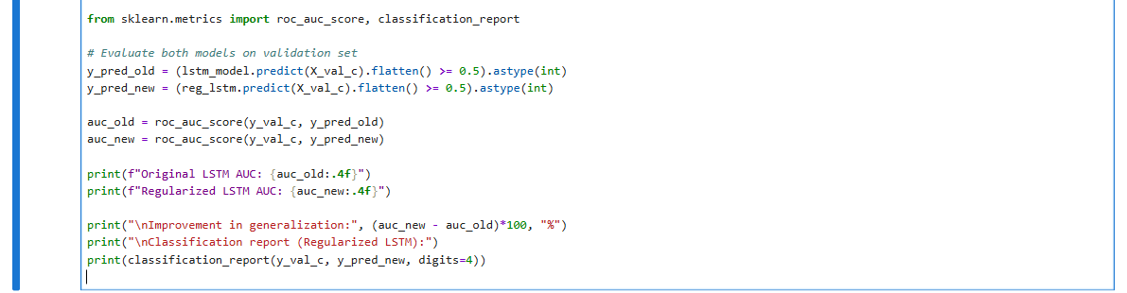
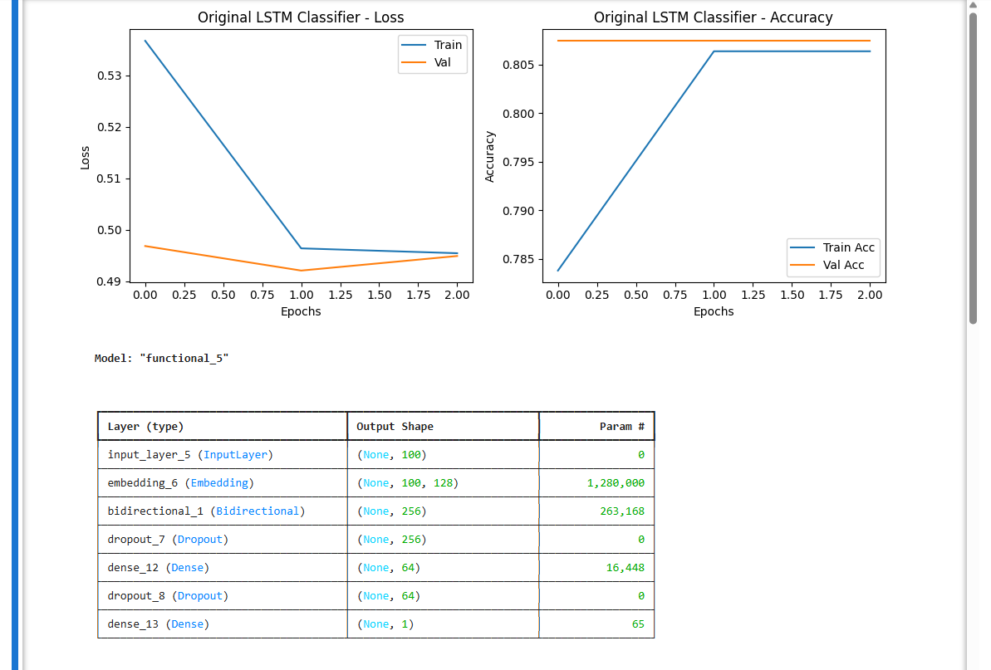
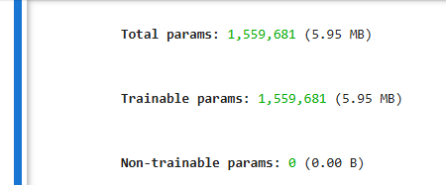
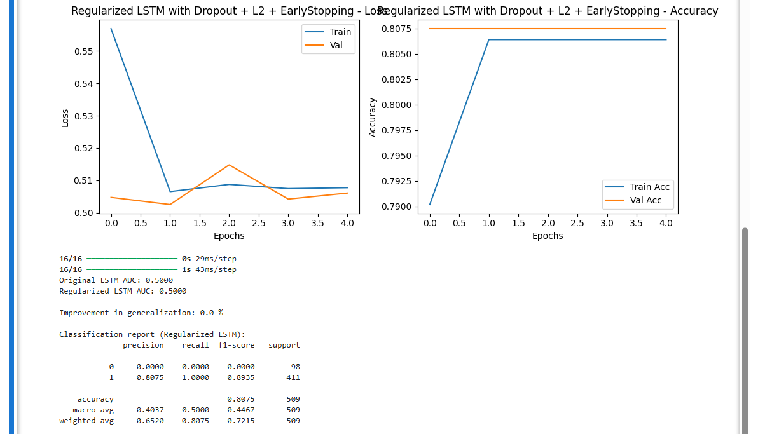

h.
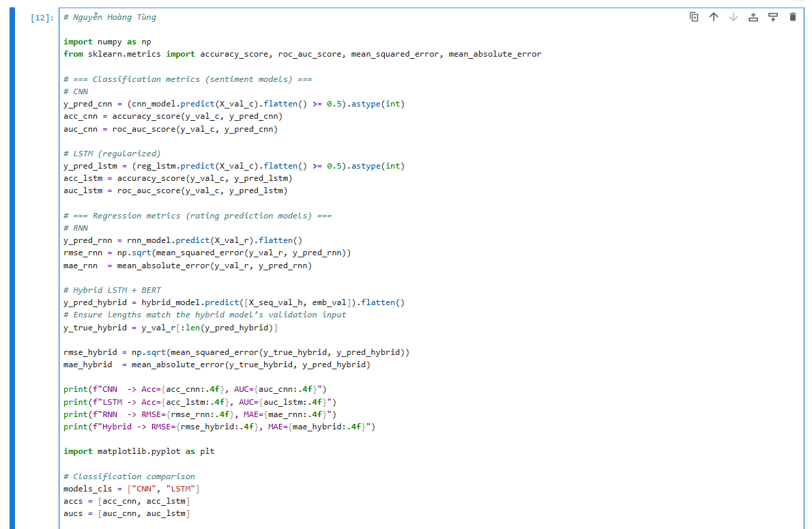
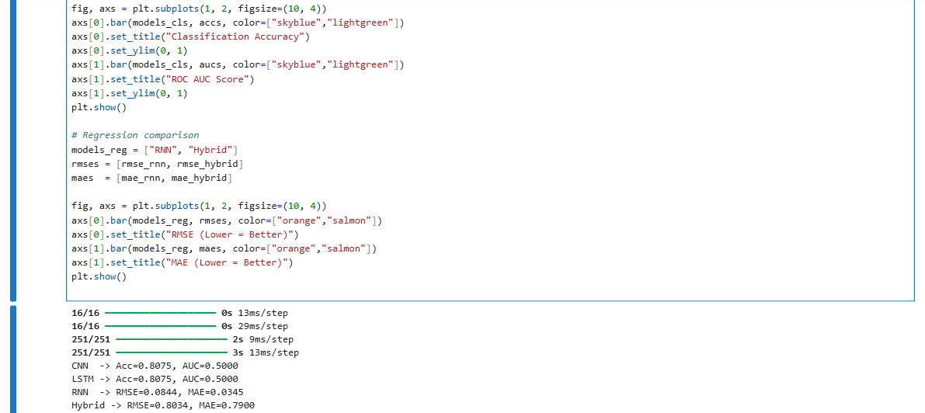
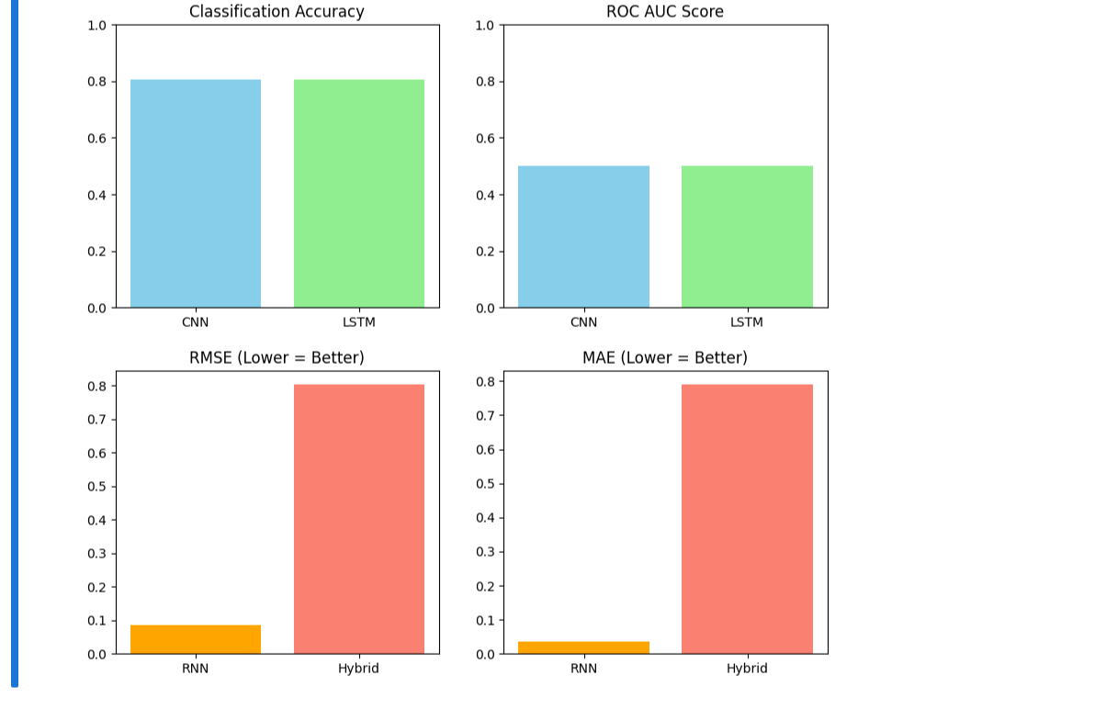

i.
